Distributed on March 23, 2015

Due: March 30, 2015 in Class

**Design Problem 5: Aplanatic Construction**

Aplanatic surfaces are extremely useful when you design optical system having high numerical aperture and relatively small field of view (FOV). We design a high NA monochromatic oil immersion objective lens for microscopy using the aplanatic surface combined with an off-the-shelf aspheric single element lens.

1. Construct lens model of aspheric single element lens: Model # 350240. The lens is available from LightPath Technologies. Evaluate geometrical spot size for each FOV.

Specifications

 =780nm

b) Object: at -Infinity

c) Entrance Pupil Diameter: 8mm (NA in air = 0.5)

d) FOV defined by image height: 0, 0.01, and 0.02mm

e) Stop: At the first surface of the aspheric lens.

Note: aspheric lens is a lens having surfaces which are not spherical. Single aspheric lens can compensate both spherical aberration and Coma, therefore, the lens is an aplanatic lens. The shape of the surface is defined by a base-radius of curvature, conic constant and higher-order aspheric terms (To define an aspheric surface in CodeV, please refer to “Introductory user Guide”, p169-174). To define the special glass “C550”, create macro file (DefC550.seq, see page 3) , then in the command window, type “in DefC550” Don’t forget to insert the BK7 window having a thickness of 0.25mm between the lens and image plane, otherwise, spot size would be very large.

1. By adding an aplanatic surface to the off-the-shelf aspheric lens + glass plate, design an oil immersion objective lens. Assume the index of refraction of the oil at 780nm is 1.511183 which is same as the index of refraction of BK7 at 780nm. Evaluate NA of the system using the same entrance pupil diameter as 1). Obtain improvement factor of the NA. Evaluate spot size for each FOV.

Note: The lens system consists of 1) t=3.69mm Aspheric Lens -> 2) 0.5mm Air space > 3) 0.25mm Glass Plate -> 4) 0.1676mm Air space -> 5) BK7 Aplanatic surface (index of refraction: n)-> Planer interface -> Oil layer (index of refraction: n). We assume the same index of refraction for the Aplanatic surface and for oil.

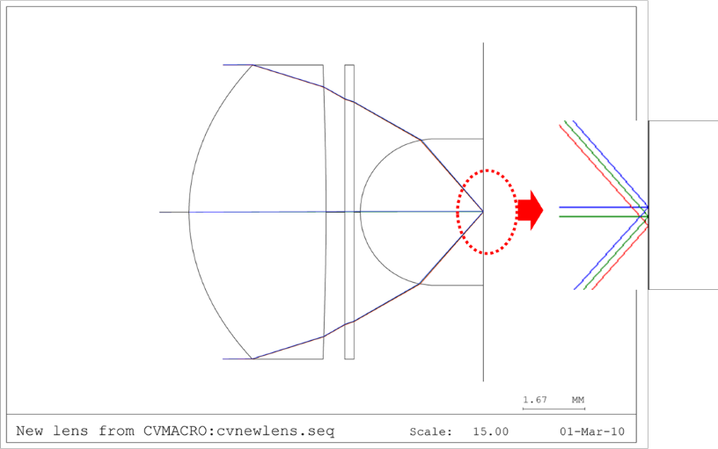

1. Redesign and evaluate the system using a glass material having higher index of refraction for the aplanatic surface. Assume that you can use the same index of refraction for the matching oil as the glass material used for the aplanatic surface. Obtain improvement factor of the NA. Evaluate spot size for each FOV.

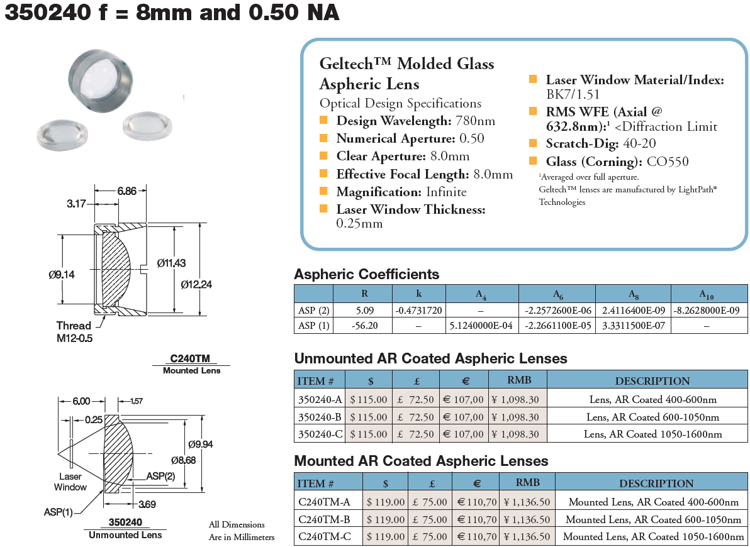

http://www.thorlabs.com/catalogPages/753.pdf

!DefC550.seq

PRV

PWL 550.0

PWL 550.0

'C0550' LAU 2.5275 -0.00824759 0.0161384 0.000710762 -0.735332e-4 0.655454e-5

END